Title : Prepare setup for Mininet network emulation environment with the help of Virtualbox and Mininet. Demonstrate the basic commands in Mininet and emulate different custom network topology (Simple, Linear, and Tree).View flow tables.
Name : - Mehatab Mahibub Sanadi
Roll No. : - CO4050
Class : - BE Computer
Subject : - Software Defined Networks
*********************************************************************
Step 1: Install Mininet in Ubuntu
Open terminal and run:
sudo apt update
sudo apt upgrade -y
Install Mininet:
sudo apt install mininet -y
Verify installation:
mn --version
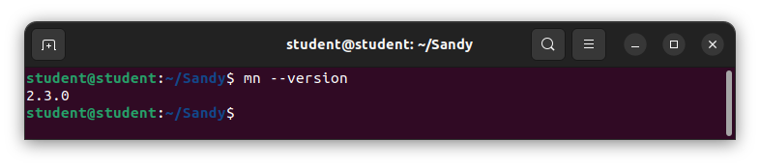
Step 2: Install Open vSwitch (for flow tables)
sudo apt install openvswitch-switch -y
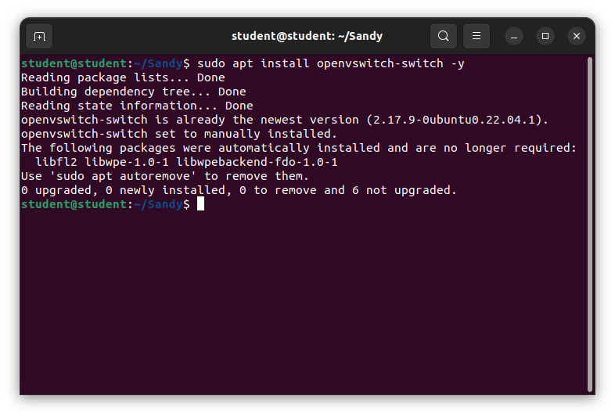
Step 3: Start Mininet (Default Topology)
sudo mn
This creates:
2 hosts (h1, h2)
1 switch (s1)
1 controller (c0)
You will see:
mininet>
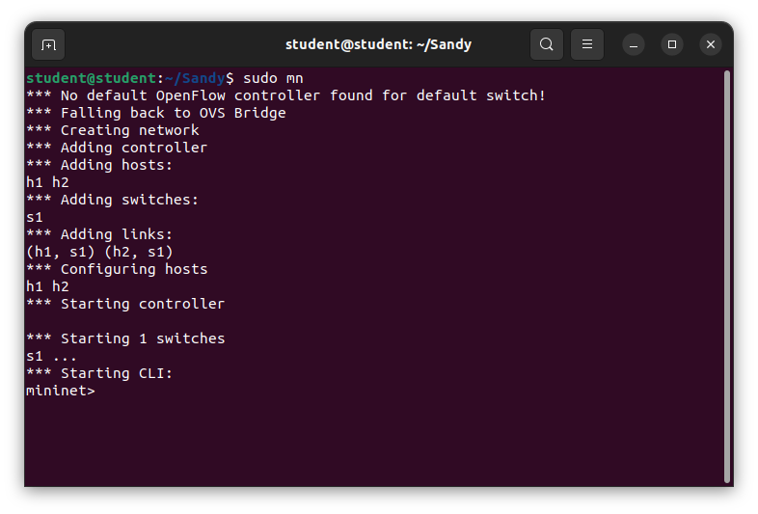

Step 4: Run Basic Commands
Show help:
help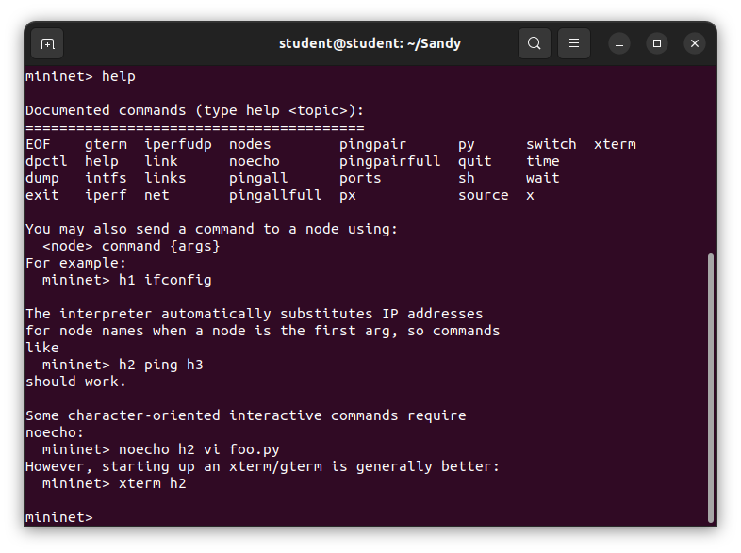
Show nodes:
nodes
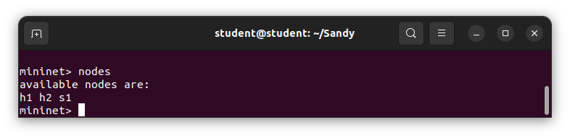

Show network links:
net
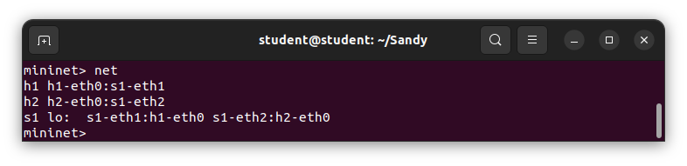
Test connectivity:
h1 ping h2
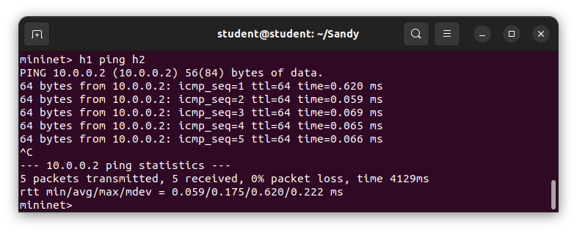
Ping all hosts:
Pingall
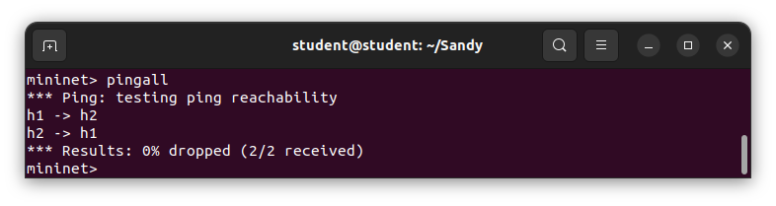

Show node details:
Dump
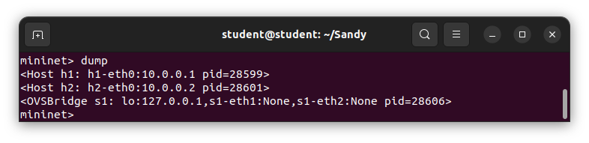
Exit Mininet
exit
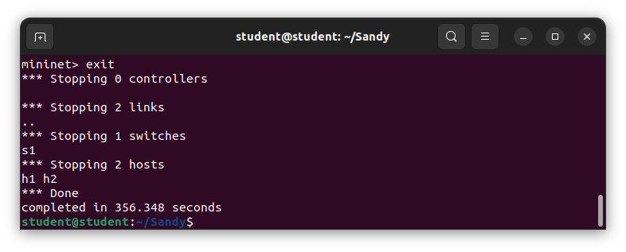
Step 5: Create Different Topologies Verify Each Topology
Inside Mininet:
nodes
net
pingall
1. Simple (Minimal) Topology
sudo mn --topo minimal
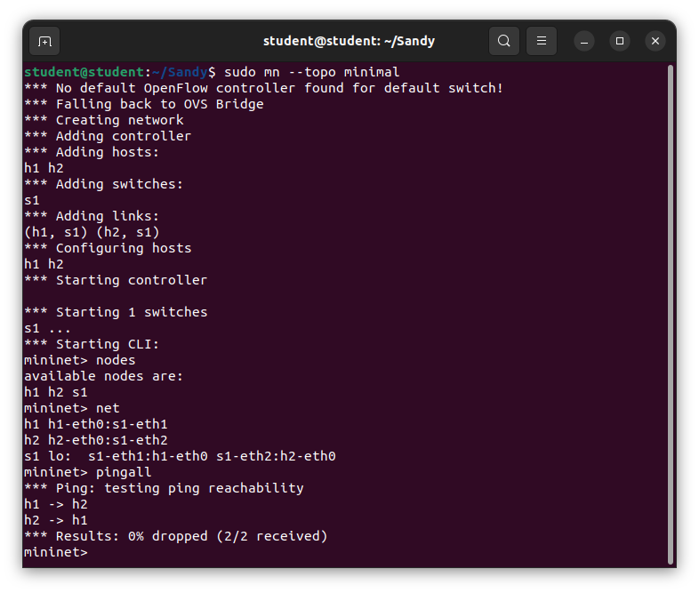
2. Single Topology (1 switch, N hosts)
sudo mn --topo single,3
(3 hosts connected to 1 switch)
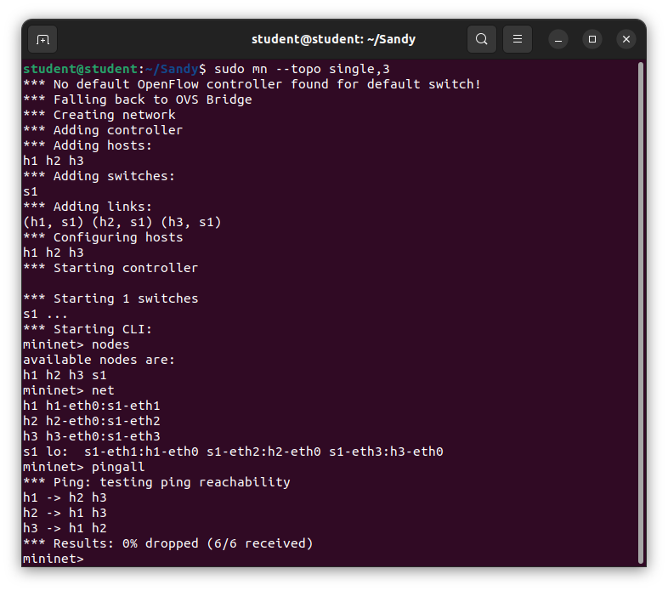
3. Linear Topology
sudo mn --topo linear,3
(3 switches in a line, each with a host)
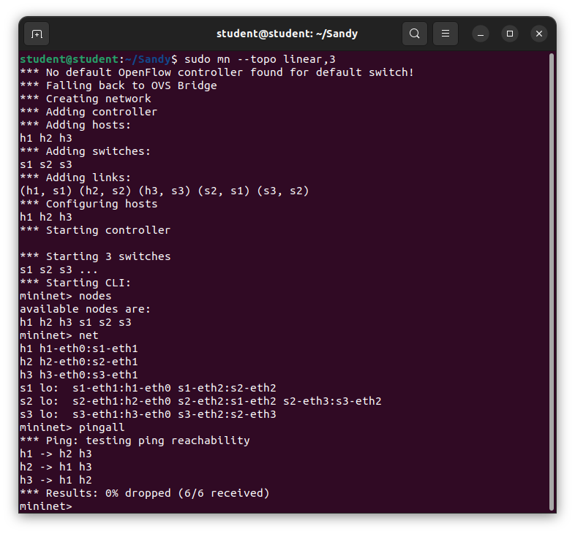
4. Tree Topology
sudo mn --topo tree,depth=2,fanout=2
(Hierarchical structure)
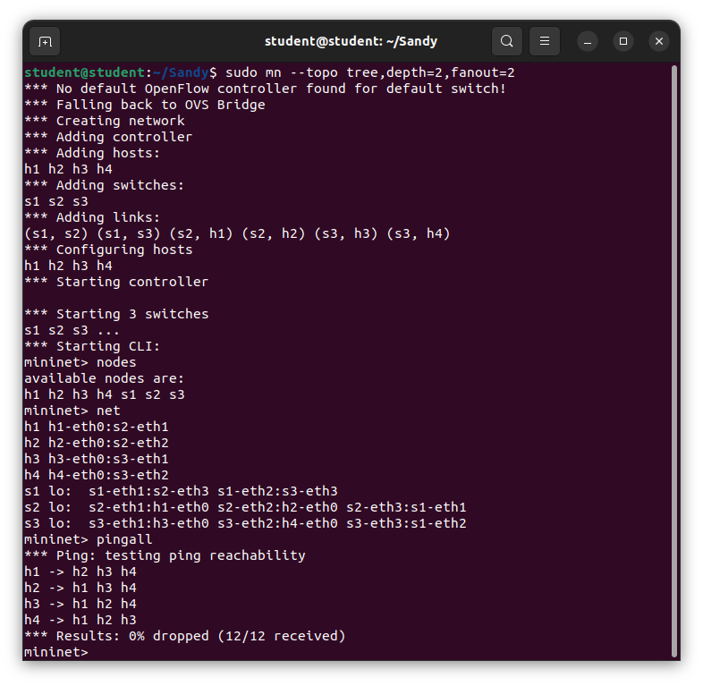
5. Reversed Topology
sudo mn --topo reversed,3
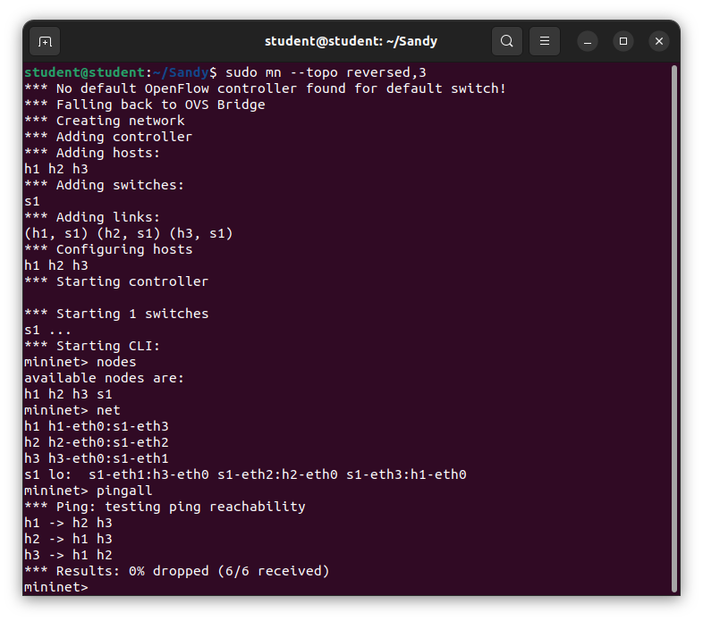
Step 6: View Flow Tables
Open new terminal (don’t close Mininet or run after starting topology):
Check switch name:
sudo ovs-vsctl show
Usually switch is s1
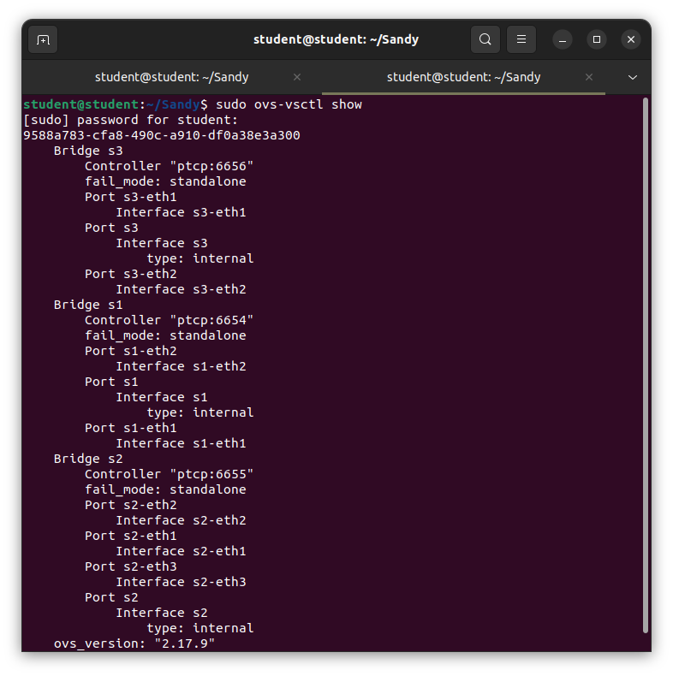
Dump flow table:
sudo ovs-ofctl dump-flows s1
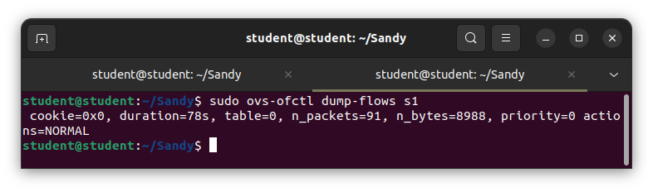
Step 7: Clean Mininet
After each run:
sudo mn -c
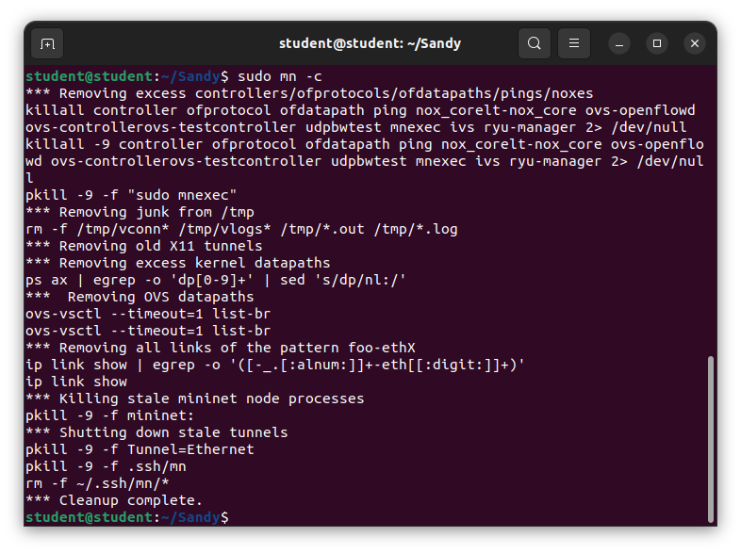
Prevents errors like:
"Error: Unable to connect to controller"
"Switch already exists"

Conclusion: We learn how to install Mininet and basic commands, and how to create topology.

